A portfolio for the class fitness walking exercise
Sometimes students look for the cheapest and quick way to keep their body health and performance in more productive way but most do not understand how walking is crucial in this aspect. It may sound as time wasting thing but the truth is walking is absolutely free and evidence-based approach to help student stay fit.
In learning institution where students sit for many hours while undertaking their studies, it advisable to help them become physically healthy, be it in games, gym or walking. There are several ways in which administration can help people towards in walking. One is to provide comfortable clothes and shoes, then create a policy and schedule for the walking and finally come up with a walking route. A walking route map is important in that they not only encourage people to take a walking exercise, but they also help them to explore the communities surrounding their living area.
In this case my outdoor walking route revolves around Philadelphia. In my case, the route should start at my home in Wharton Street and the destination is Philadelphia Museum of Art. Having this in mind, I can have 5 different routes for me to reach there as shown in the map. The walk have an average of 3 miles from home to Museum and different consideration may be involved when deciding which route to take.
- Map of my Walking Environment

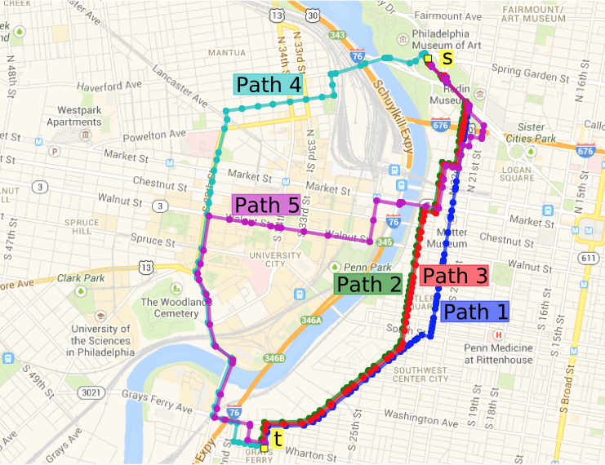
Philadelphia
- Reason for Choosing this walking Route (Path 1).
As much as I want to keep my body fit by walking along the longer path such as Path 4, I have to consider some aspect which are crucial such as the safety and security issues. Path 4 has some areas with gangs and crooks who may compromise my safety while walking alone. In that case, I have to do away with that route. All the other route apart from path one are familiar to me and they got no proper pedestrian lane for a safe walking exercise. Therefore, path one remains a suitable route for me, as I may have much to explore, and my safety may remain intact.
- The mileage.
These paths indicated in the map have different distances from point t to point s. Path 5 being the longest with 4 miles, followed by path 4 which has 3.6 miles. Path 3, 2 and 1 are relatively equal distance of 2. 9 miles. Walking for a single mile may take about 30 minutes and in this case, my preferred path may take me three hours for moving from point t to s and back to t.
From research, taking a brisk walk of about three hours in a week helps in meeting the guidelines of Physical activity in United States.
- Images
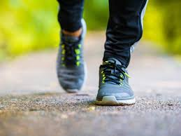
Comfortable shoes are necessary in this exercise.


The use of google map in the phones helps in maintain the direction while walking

The correct way of walking to keep the body fit and lose weight. In case one have security issues with the route, it is advisable to look for a partner in the exercise.


Having a wrist watch helps in timing yourself.

